Technical Proposal
IoT-enabled Production Downtime Tracker
(Lost Time and Quality Defect Monitoring)
Web Application + Mobile Applications (Android and iOS) | Developed From Scratch

Prepared by: Riseup Labs
Date: 10/2/26

1. Executive Summary
This proposal describes the end-to-end development of an IoT-enabled Production Downtime Tracker to monitor production line stoppages ("Lost Time") and manage quality defect escalation (Red Tag system) in real time. The solution will connect factory floor IoT devices (RFID-enabled edge controllers controlling Andon tower lights and optional machine-stop relays) to a central backend platform, delivering role-based dashboards, notifications (push and SMS), analytics, and Excel exports through a web portal and mobile applications (Android and iOS).
The system will be developed from scratch and delivered as a secure, scalable, and maintainable platform, designed for low-latency event ingestion, resilient operation during network interruptions, and clear auditability of actions and events.

2. Project Understanding and Objectives
Based on the provided Scope of Work (SOW), the solution targets the following objectives:
- Monitor line stoppages in real time and capture start/end timestamps.
- Automate Andon/Ambulance light activation during issues.
- Implement Red Tag escalation logic (warning and critical thresholds).
- Trigger escalation alerts via push notifications and SMS based on time and tag thresholds.
- Calculate lost time by line, department, shift, and custom date ranges and provide management dashboards.
- Provide exportable reports in Excel format for operational review and compliance evidence.

3. Functional Scope

3.1 Scenario 1 - Line Stop via Supervisor RFID
A supervisor uses an RFID card to start and end a downtime event:
- Card In: IoT device turns Andon light ON and sends a start event payload (Line ID, Supervisor ID, timestamp).
- Card Out: IoT device turns Andon light OFF and sends an end event payload (timestamp).
- Backend computes Lost Time as End Time minus Start Time, stores it per line/department/supervisor/date-time, and updates dashboards in real time.

3.2 Web Application (Role-Based)
- Real-time line status dashboard (Running/Stopped) with filters by department/line.
- Department-wise and line-wise lost time reports with daily/weekly/monthly/yearly and custom ranges.
- Red tag tracking dashboards and historical views.
- Excel report download for operational review.
- Administration: manage departments, lines, IoT devices, users, roles, escalation rules, and notification templates.

3.3 Mobile Applications (Android and iOS)
- Live line status view and quick drill-down to line history.
- Push notifications for line stops, prolonged downtime, 3rd Red Tag warnings, and 5th Red Tag critical events.
- Lost time summary and department performance views for management.
- Secure login with role-based access and data visibility.

3.5 Notifications and Escalation Matrix
The platform will support configurable escalation rules. Default logic (as per SOW) includes:
Trigger | Notification Type | Recipients (Typical)
Instant (Card In / Line Stop Start) | Push | Floor Supervisor / Line Lead
10 minutes without Card Out | Push + SMS | Production Manager
3rd Red Tag used | Push + SMS | Supervisor / Executive staff (configurable)
5th Red Tag used | Critical SMS + Push | PM, QAM, Factory Manager (configurable)

4. Proposed Solution Overview
The solution follows an event-driven IoT architecture: edge devices generate events (RFID in/out and Red Tag scans), a secure ingestion layer receives events via HTTPS or MQTT, the backend persists and processes events to compute lost time and apply escalation rules, and user applications consume real-time updates and analytics through APIs and WebSockets.

5. Proposed Technical Approach

5.1 Edge Device and Firmware Design
Each production line will have a dedicated IoT device that reads RFID events, drives Andon tower lights, and controls a relay output to stop specific machines. The firmware will be designed for reliability in factory conditions:
- State machine driven: explicit states (Idle, Stopped, Escalated, Critical) to prevent inconsistent outputs.
- Store-and-forward buffering: queue events locally if the network is down; auto-retry with backoff and replay.
- Time synchronization: periodic NTP sync and server-side timestamp validation to avoid clock drift issues.
- Device health telemetry: heartbeat, network status, and error reporting to support maintenance.
- Secure device identity: per-device credentials (API key or mutual TLS certificate), with revocation capability.

5.2 Connectivity and Protocols (HTTPS REST vs MQTT)
The ingestion layer will support HTTPS REST for simplicity and MQTT for low-latency publish/subscribe messaging. MQTT is a lightweight protocol designed for constrained environments and is widely used in IoT deployments.
Recommended approach:
- MQTT over TLS for real-time event streaming (preferred for high event frequency and rapid status updates).
- HTTPS REST as a fallback channel and for device provisioning/diagnostics.
- Idempotent event processing (event_id + device_id) to avoid duplicates during retries.

5.3 Backend Event Processing and Rules Engine
The backend will process incoming events in near real time to compute lost time and apply escalation rules. Key responsibilities include validation, persistence, calculations, and triggering outbound notifications.
- Event validation and schema enforcement (line/device/user mapping).
- Lost time calculation and aggregation (by line, department, date range).
- Red Tag counters and threshold-based escalation (3rd/4th/5th tag rules).
- Downtime duration tracking to trigger time-based escalations (e.g., 10-minute rule).
- Audit logging for admin actions and critical events.

5.4 Real-Time Dashboards
The web dashboard will present real-time line status using WebSockets. Mobile apps will receive push notifications and can optionally show live status via WebSocket or periodic polling, depending on network constraints and battery considerations.

5.5 Notification and SMS Delivery
Push notifications will be delivered using Firebase Cloud Messaging (FCM). SMS will be delivered via an integrated SMS gateway (local operator aggregator or a global provider such as Twilio, depending on the deployment region and compliance requirements).
- Template-based notifications (message templates per event type and role).
- Escalation scheduler with retry queue and delivery status tracking.
- Recipient resolution based on RBAC, department/line ownership, and escalation matrix configuration.

5.6 Reporting and Analytics
Analytics will support operational decision-making and root-cause investigation. Reports will be exportable to Excel and support filters by department, line, supervisor, and date range.
- Total lost time per line/department/factory with trend views (daily/weekly/monthly).
- Red tag usage statistics and top recurring defect lines.
- Machine-stop frequency and correlation to downtime.
- Data quality checks: missing end events, overlapping downtime events, and abnormal durations.

6. Technical Diagrams

6.1 Figure 1 - High-Level Solution Architecture

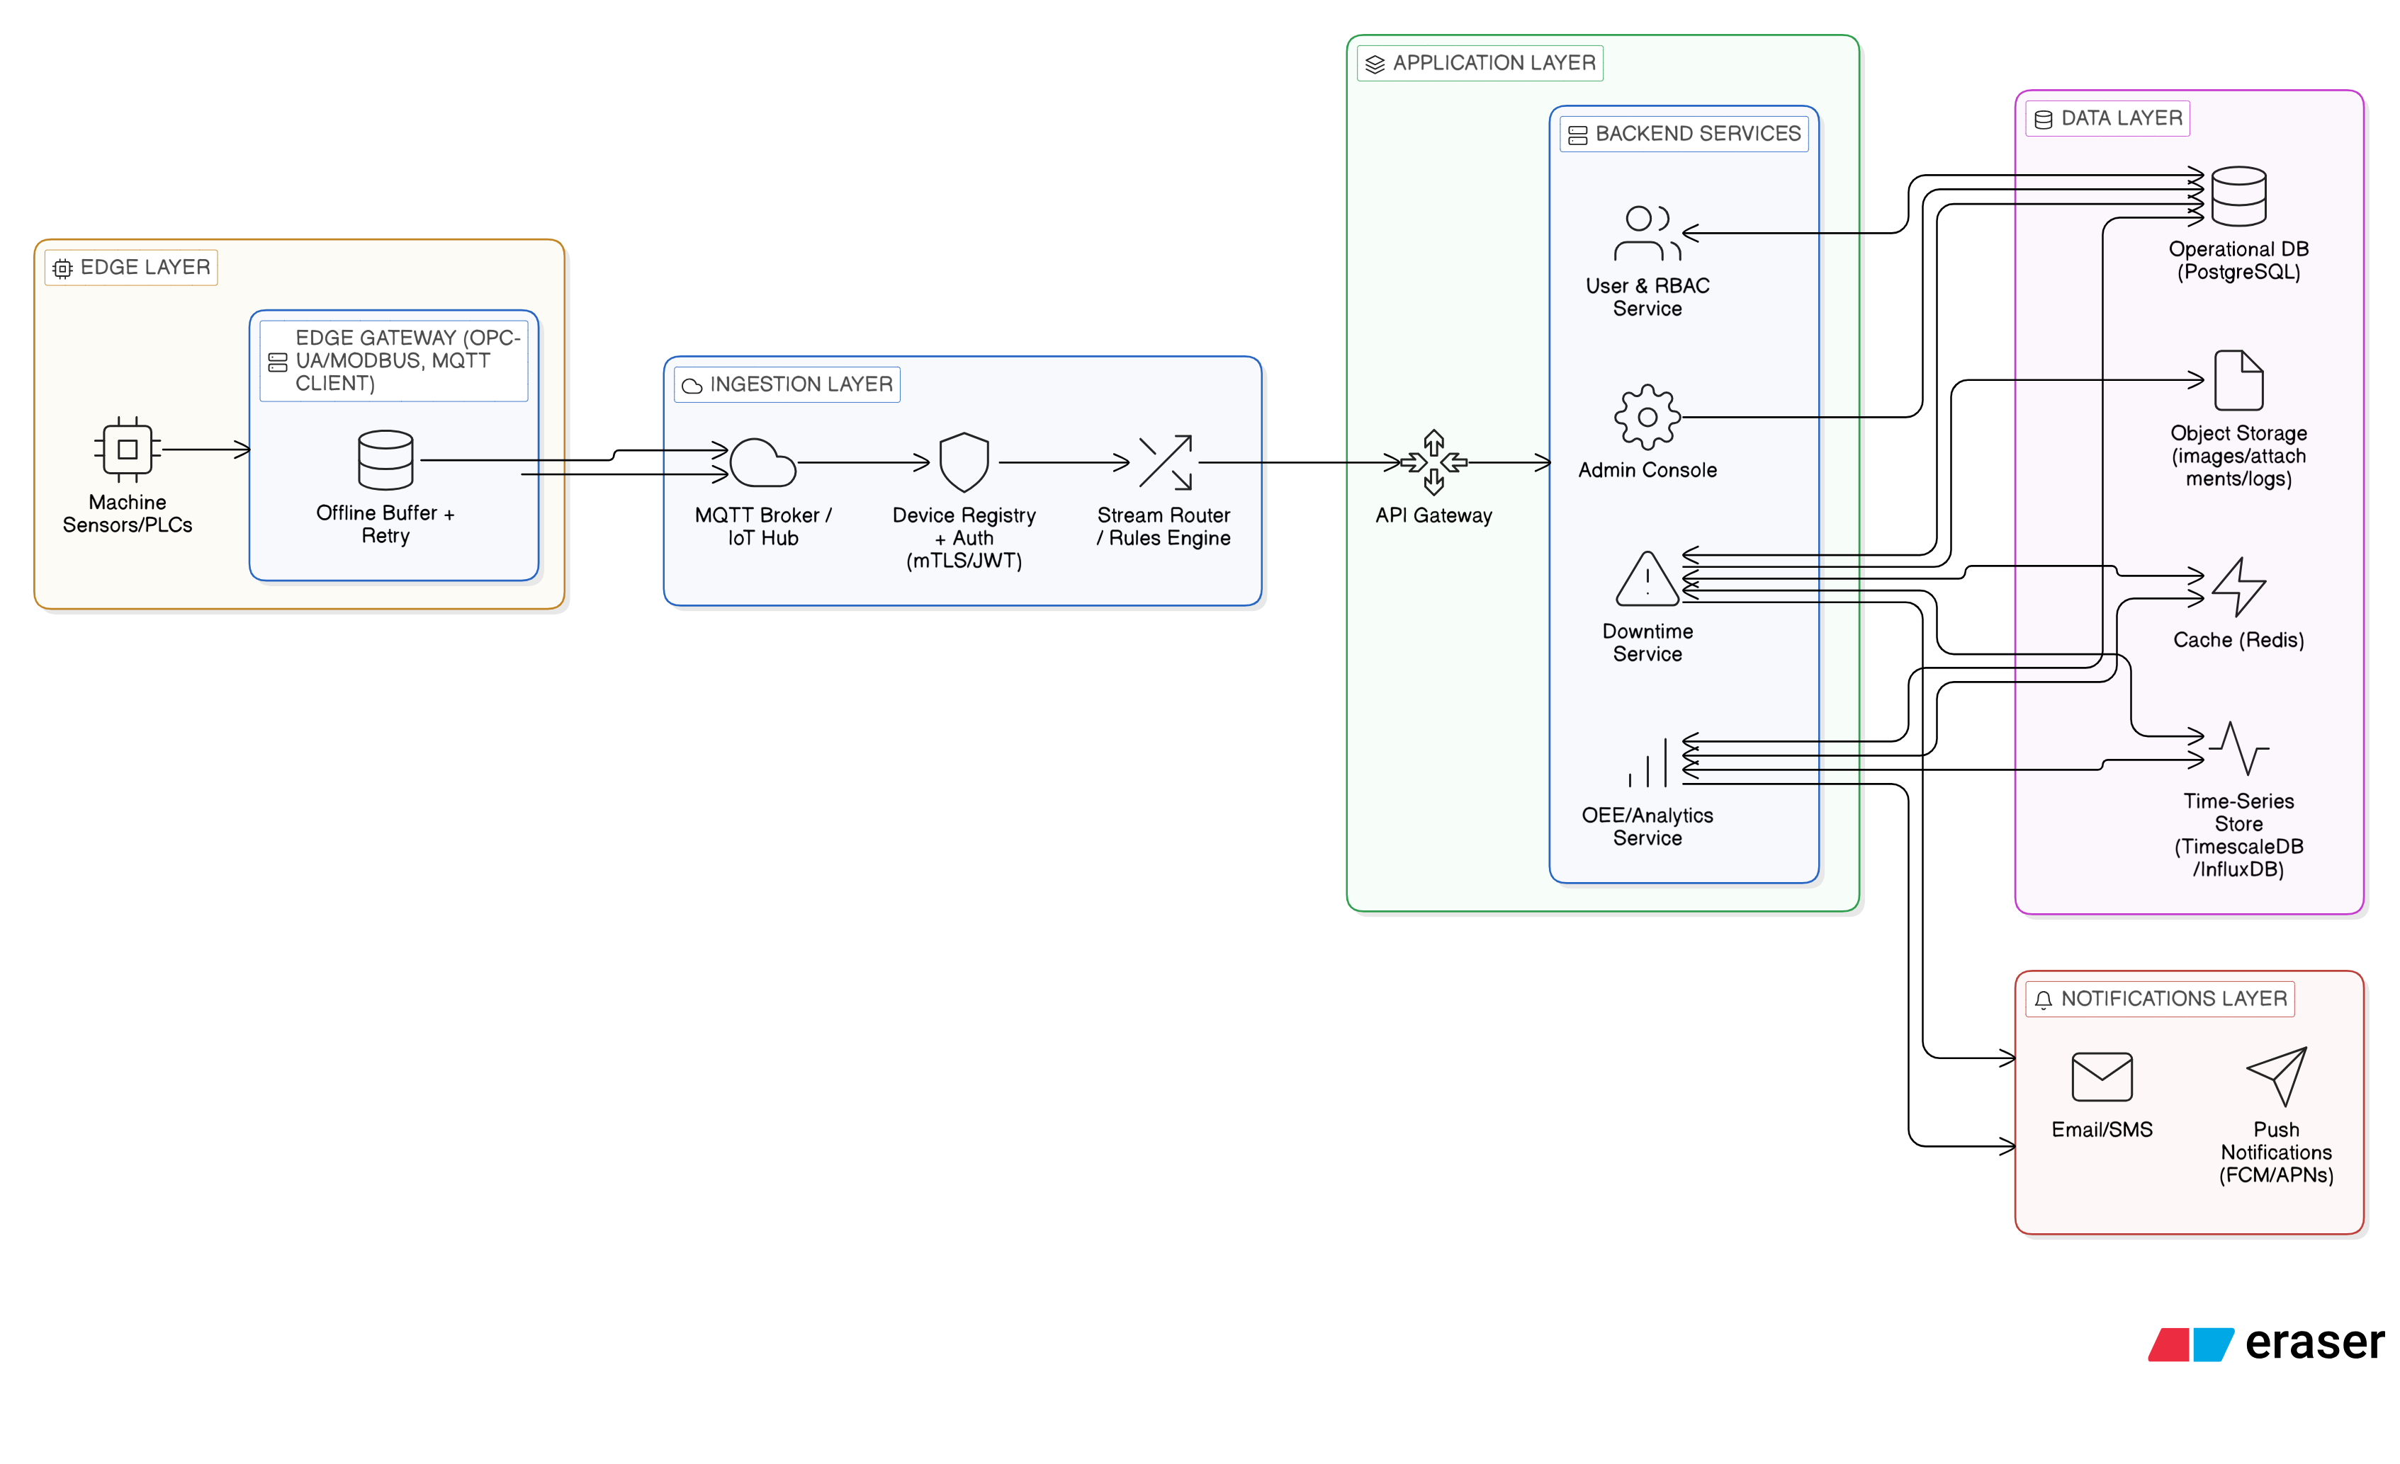 6.2 Figure 2 - Scenario 1 Sequence (RFID Card In/Out)

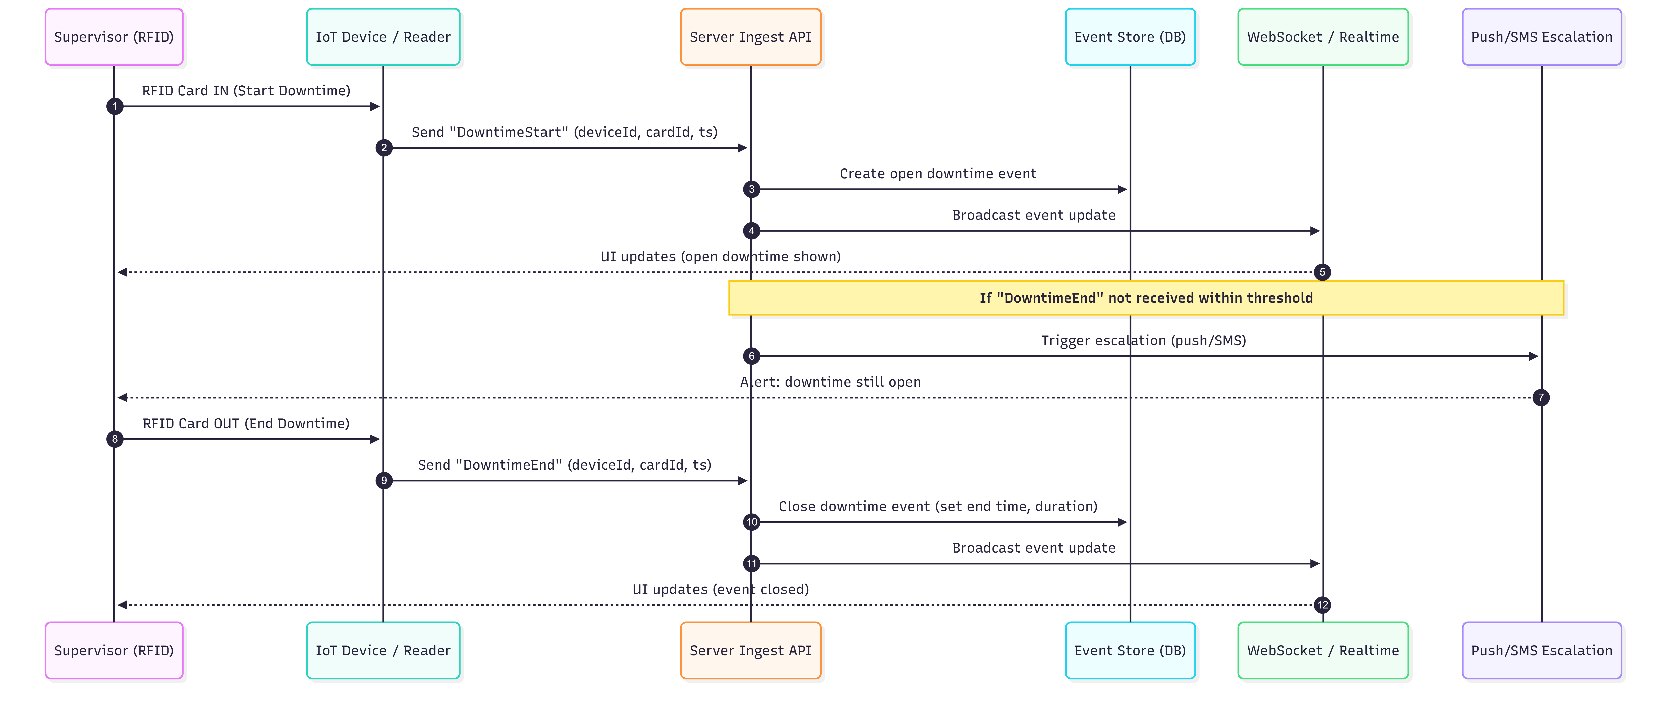

6.3 Figure 3 - Red Tag Escalation Flow (3rd/4th/5th Tag)

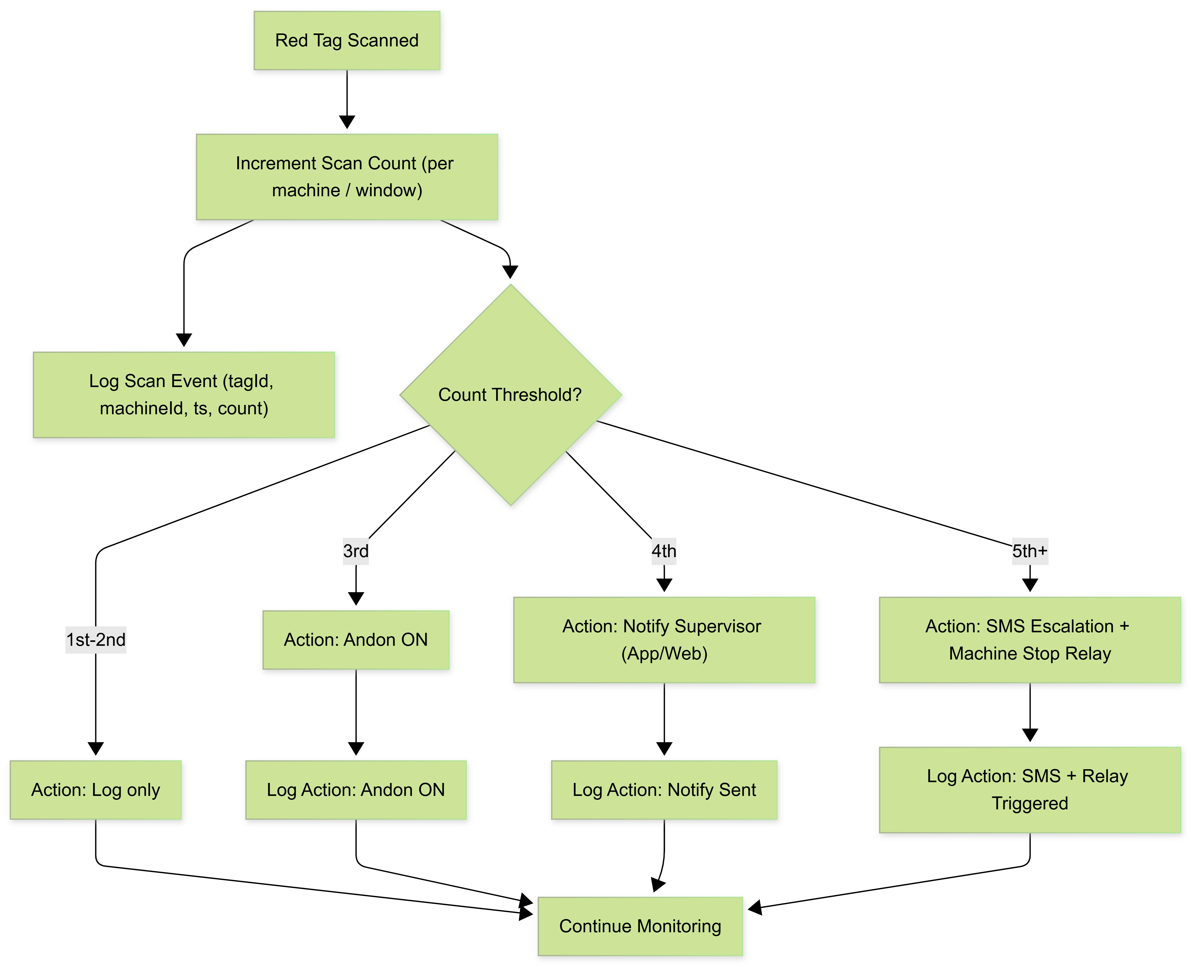

7. High-Level Data Model (Text)
The following entities form the minimum viable data model to support traceability, analytics, and role-based access.
Entity | Purpose
Factory | Factory profile and global settings.
Department | Grouping of production lines; reporting dimension.
ProductionLine | Line identifier, location, department mapping, status.
IoTDevice | Device identity, line binding, firmware version, last seen, credentials.
User | Login identity; mapped to roles and departments/lines.
Role | Admin, Manager, Supervisor, etc. with permissions.
DowntimeEvent | Start/end timestamps, supervisor, line, reason (optional), computed duration.
RedTagEvent | Tag scan timestamp, line, defect category (optional), current count.
EscalationRule | Threshold rules (time and count), recipients, templates.
NotificationLog | Push/SMS payload, delivery status, timestamps, retry count.
AuditLog | Admin actions: config changes, user/device assignments, rule changes.

8. Proposed Technical Stack
The following stack is recommended to meet low-latency ingestion, real-time dashboards, secure operations, and long-term maintainability.
Layer | Recommended Technology | Notes / Justification
Edge Firmware | ESP-IDF (C/C++) or Arduino C++; optional MicroPython for rapid prototyping | Industrial stability, control of peripherals (RFID/relay), OTA-ready.
Device Messaging | MQTT over TLS; HTTPS REST fallback | MQTT supports lightweight publish/subscribe for real-time IoT messaging.
MQTT Broker | EMQX or Eclipse Mosquitto | Production-grade broker; supports authentication, ACLs, and monitoring.
API Gateway / Reverse Proxy | Nginx | TLS termination, routing, rate limiting, and headers hardening.
Backend Services | Python Django + Django REST Framework | Rapid delivery with mature ecosystem; strong RBAC, ORM, and admin tooling.
Async / Jobs | Celery + Redis | Scheduler for escalations, retries, and report generation.
Real-Time Updates | WebSockets (Socket.IO or Django Channels) | Push line status updates to dashboards.
Database | PostgreSQL (optionally TimescaleDB extension) | Reliable relational store for events and reporting; time-series optimization optional.
Cache / State | Redis | Real-time status cache, throttling, and job queues.
Web Frontend | React.js or Next.js | Fast UI, component ecosystem, and integration with WebSockets.
Mobile Apps | Flutter (Android + iOS) | Single codebase; aligns with SOW stack and supports FCM.
Push Notifications | Firebase Cloud Messaging (FCM) | Cross-platform push delivery.
SMS | Local SMS aggregator API or Twilio | Configurable provider based on region and compliance.
Observability | Prometheus/Grafana + centralized logs (ELK/OpenSearch) + Sentry | Monitoring, alerting, and error tracking.
Containerization | Docker; optional Kubernetes for scale | Portable deployments; simple scaling and environment parity.
CI/CD | GitHub Actions/GitLab CI; mobile build pipeline (Fastlane) | Automated build, test, and release workflows.

9. Development Methodology
We propose an Agile delivery model with short iterations to reduce risk and validate factory-floor workflows early. Firmware, backend, web, and mobile streams will be developed in parallel with frequent integration checkpoints.

9.1 Delivery Plan (From Scratch)
Inception and Detailed Requirements
- Confirm factory process details (line mapping, roles, escalation hierarchy, reporting formats).
- Finalize device specifications and wiring diagrams for Andon lights and relay outputs.
- Define data model, APIs, MQTT topics, and acceptance criteria.
Core Platform and Device Integration (MVP)
- Implement device provisioning, secure ingestion (MQTT/HTTPS), and core event storage.
- Deliver Scenario 1 (RFID in/out) end-to-end with real-time web dashboard.
- Initial push notifications for downtime start and time-based escalation.
Red Tag Escalation and Reporting
- Implement thresholds, rule engine, and notification templates.
- Integrate SMS gateway and delivery status logging.
- Deliver reporting module, Excel exports, and management dashboards.
Mobile Apps, Hardening, and Rollout
- Deliver Flutter mobile apps for Android and iOS with secure authentication and push notifications.
- Performance tuning, failover testing, and security hardening.
- Pilot rollout to selected lines, user training, and production deployment.

9.2 Deliverable Governance
- Sprint planning and review with product owner and factory stakeholders.
- Weekly demos for end-to-end flows (device -> backend -> dashboard -> notification).
- Definition of Done includes code review, automated tests, and deployment to staging.

10. Testing and Quality Assurance
A dedicated QA plan will ensure reliability across hardware, network variability, and multi-platform user interfaces. Testing will be performed continuously throughout development and repeated during pilot rollout.

10.1 Test Strategy
Firmware and Hardware-in-the-Loop (HIL) Testing
- RFID read accuracy and debouncing; card in/out detection edge cases.
- Relay output validation for Andon lights and machine stop circuits.
- Network failure tests (WiFi drops, packet loss) and retry behavior verification.
- Soak tests for continuous operation and power interruption recovery.
Backend and API Testing
- Unit tests for rules engine and lost-time calculations (including overlapping and missing events).
- API contract tests (OpenAPI) and automated regression suite.
- Idempotency and duplicate event handling under retries.
- Load tests for concurrent device events and real-time dashboard subscribers.
Web and Mobile Testing
- UI functional testing for dashboards, filters, and exports.
- Cross-browser testing for web; device matrix testing for mobile.
- Push notification delivery tests for Android and iOS; permission handling.
- Offline and poor-network usability tests for management users.
Security Testing
- Authentication and authorization testing (RBAC), including object-level access checks.
- API security testing aligned to OWASP API Security Top 10.
- Transport security validation (TLS), secrets scanning, and dependency checks.

Fig: QA Test Process

11. Security, Privacy, and Compliance Considerations
The solution will be designed with defense-in-depth to protect device communications, application access, and sensitive operational data.
- Secure transport: TLS for all device and user communications; MQTT over TLS when enabled.
- Device identity and access: per-device credentials, revocation, and rate limiting at ingestion.
- Role-based access control (RBAC): least privilege roles for Admin/Manager/Supervisor with line/department scoping.
- Audit logs: immutable logs for configuration changes and critical events (rule changes, device reassignment).
- Data protection: encryption at rest where supported, regular backups, and defined retention policies.
- Operational security: centralized logging, anomaly alerts, and vulnerability management for dependencies.

12. Deliverables

12.1 Software Deliverables
- Backend platform (APIs, event processing, rules engine, reporting module).
- Web application (Admin and management dashboards, real-time views, Excel exports).
- Mobile applications (Flutter) for Android and iOS with push notifications.
- Notification services (FCM integration, SMS gateway integration, escalation scheduler).
- System administration tools (device provisioning, user/role management, configuration screens).

12.2 Technical Documentation and Handover
- Solution architecture document and deployment guide (cloud/on-prem options).
- API documentation (OpenAPI/Swagger) and MQTT topic specification.
- Firmware documentation (wiring, configuration, OTA update process).
- Test plan, test reports, and UAT sign-off checklist.
- Runbook for operations (monitoring, backups, incident response, and escalation).
- Training sessions for admins and operational users.

13. Assumptions, Dependencies, and Risks

13.1 Key Assumptions
- Factory network connectivity (WiFi/Ethernet) is available at each production line or can be provisioned.
- RFID cards/tags and hardware components are available and approved for factory use.
- Stakeholders will provide escalation recipients (phone numbers, roles) and approve messaging templates.
- For iOS deployment, an Apple Developer account will be available for App Store/TestFlight distribution (or enterprise distribution if required).

13.2 Primary Risks and Mitigations
Risk | Impact | Mitigation
Unstable network on factory floor | Delayed event delivery and real-time visibility gaps | Local buffering on devices; MQTT with QoS; health monitoring and alerts.
Incorrect time capture (clock drift) | Inaccurate lost-time calculations | NTP sync; server-side validation; reconciliation reports.
Hardware integration variance across lines | Inconsistent Andon/relay behavior | Standard wiring spec; pilot installation; HIL tests.
Notification overload / false positives | Reduced trust and slower response | Configurable escalation matrix; throttling; acknowledgment workflow (optional).

